WEEK 1 TASK – PLANNING AND AIRFRAME LAYOUT

1. Executive Summary
This Week 1 task establishes a disciplined preliminary approach to an aircraft airframe layout before hands-on modelling. The study uses a conceptual fixed-wing electric UAV as a reference vehicle because it provides a clear, manageable case for learning airframe geometry, aerodynamic sizing, weight estimation, stability considerations, packaging, and design documentation.
The proposed concept uses a conventional tractor configuration, a moderate-aspect-ratio main wing, conventional horizontal and vertical tails, a forward propulsion unit, and an internal electronics/battery bay. The design process starts with requirements and assumptions, then proceeds through weight estimation, wing sizing, stability, aerodynamic checks, packaging, and a week-by-week implementation plan.
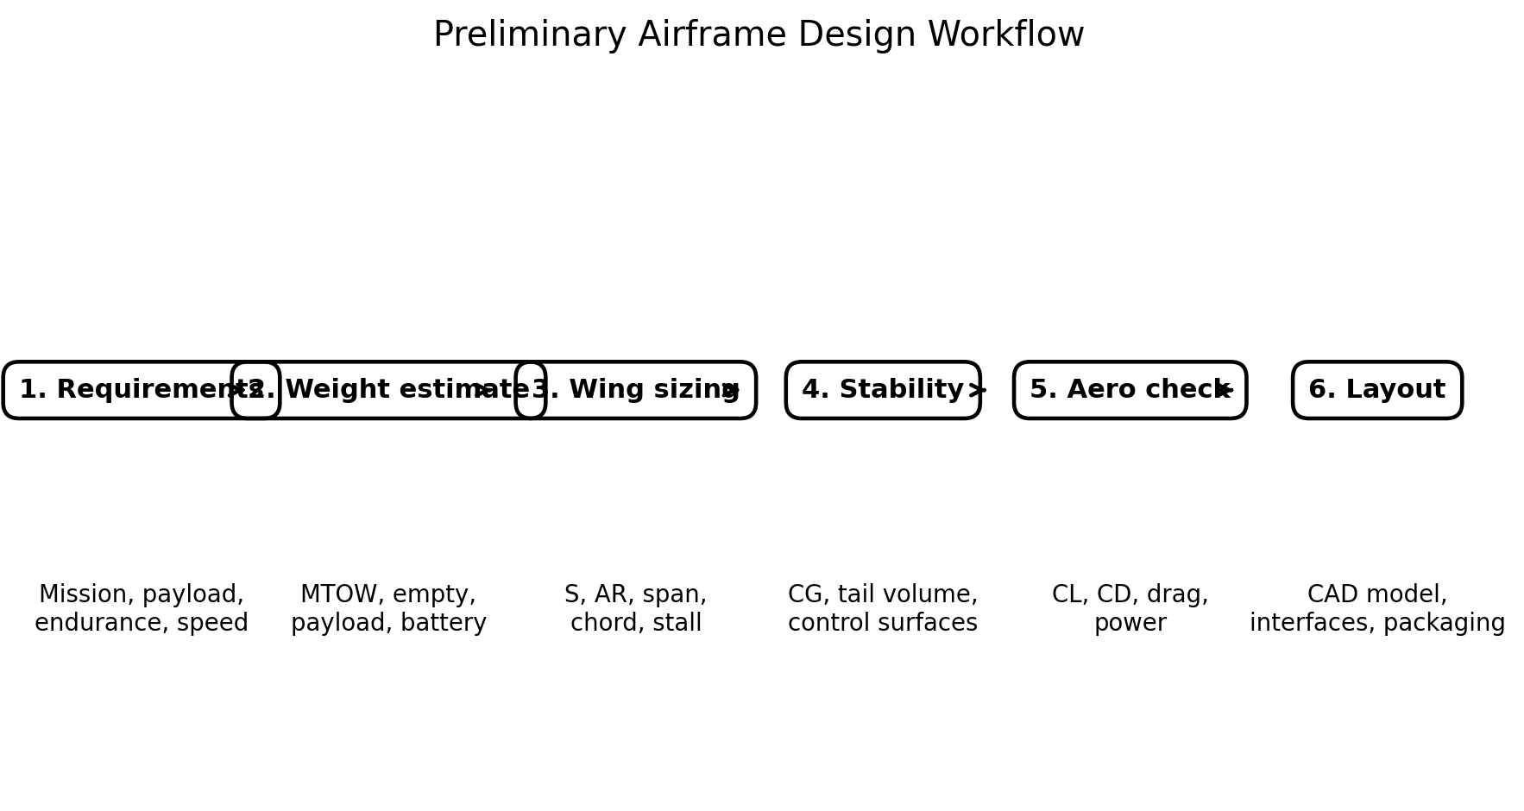
Figure 1. Preliminary design workflow used for this study.

2. Task Objective and Scope
The objective is to demonstrate how a professional designer would approach an airframe-layout problem before detailed CAD or fabrication. The work therefore emphasizes traceable assumptions, engineering calculations, reference standards, design constraints, and a repeatable workflow.
- Study the purpose and major elements of an aircraft airframe layout.
- Define a clear preliminary design problem with assumptions and constraints.
- Estimate aircraft weight and establish a preliminary mass budget.
- Size the main wing from an assumed stall-speed requirement.
- Select aspect ratio and calculate span and mean aerodynamic chord.
- Estimate cruise lift coefficient, induced drag, total drag and propulsion power.
- Perform first-order horizontal- and vertical-tail sizing using tail-volume coefficients.
- Define a preliminary CG target and show where major components should be packaged.
- Identify suitable tools, references and standards for subsequent work.
- Create a week-by-week plan leading from research to CAD and validation.

3. Design Problem Statement
Develop a preliminary airframe layout for a small fixed-wing electric UAV intended for stable, efficient flight and carrying a modest electronics/payload package. The concept should be simple enough for student-level analysis while following a professional systems-engineering sequence.
Parameter | Preliminary target / assumption | Reason
Aircraft type | Fixed-wing electric UAV | Relevant to aerospace + embedded/electronics integration
Configuration | Conventional tractor, high/shoulder wing | Simple, stable and easy to package
Maximum take-off mass | 12 kg | Reference value for calculations
Design weight | 12 × 9.81 = 117.72 N | Used for aerodynamic sizing
Target stall speed | ≈ 11.6 m/s | Provides a calculable low-speed constraint
Cruise speed | 18 m/s | Representative preliminary cruise condition
Wing aspect ratio | 8 | Moderate efficiency without excessive span
CLmax for sizing | 1.30 | Conservative preliminary assumption for a small clean wing
Air density | 1.225 kg/m³ | ISA sea-level reference for preliminary calculation
Oswald efficiency, e | 0.80 | Preliminary estimate
Zero-lift drag coefficient, CD0 | 0.035 | Preliminary estimate
Propulsive efficiency | 0.70 | Preliminary electric propulsion estimate
Mission | Stable cruise + electronics payload | Keeps the Week 1 problem focused

4. Assumptions, Constraints and Risks
Assumptions are deliberately stated so that they can be replaced later when real mission requirements are supplied.
- The aircraft is treated as a preliminary conceptual design, not an approved or certifiable aircraft.
- The aerodynamic calculations use steady, level flight and sea-level standard density.
- The wing is assumed to have CLmax ≈ 1.30 for preliminary stall sizing.
- No detailed viscous airfoil analysis, Reynolds-number correction, propeller-map analysis, flutter analysis, structural FEA, or CFD is claimed at this stage.
- A 12 kg MTOW is a design assumption and must be replaced by an actual mass estimate after component selection.
- The CG target is initially placed around 25–35% of mean aerodynamic chord, subject to stability analysis.
- The airframe must reserve volume for battery, flight controller, telemetry, GNSS/GPS, wiring, payload and propulsion electronics.
- Safety margins, material allowables and certification compliance must be addressed before any real flight vehicle is constructed or operated.

5. Professional Methods and Reference Standards
For a professional airframe-design workflow, regulatory requirements are treated as constraints rather than as a substitute for engineering analysis. For conventional small aeroplanes, FAA Part 23 and EASA CS-23 provide relevant airworthiness frameworks. The FAA identifies Part 23 as the airworthiness standard for normal, utility, acrobatic and commuter-category airplanes and lists associated airframe, systems and equipment guidance. EASA's current CS-23 material is maintained as certification specifications with associated acceptable means of compliance and guidance material.
Reference | How it is used in this project
FAA 14 CFR Part 23 / FAA small-airplane guidance | Reference framework for small-aircraft airworthiness, airframe and systems considerations.
FAA AC 23-19 — Airframe Guide for Certification of Part 23 Airplanes | Useful reference for thinking about airframe certification and structural substantiation.
FAA AC 23-17 — Systems and Equipment Guide | Reference for aircraft systems/equipment integration and installation thinking.
EASA CS-23, Amendment 6 / AMC & GM Issue 5 | Current European certification framework for normal-category aeroplanes; useful as a regulatory reference where applicable.
Textbook / aerodynamic references | Used for preliminary lift, drag, stability and sizing equations; exact edition should be recorded in the final engineering report.
Official sources checked for this plan:
- FAA — Small Airplanes: Regulations, Policy and Guidance: https://www.faa.gov/aircraft/air_cert/design_approvals/small_airplanes/small_airplanes_regs
- EASA — CS-23 Amendment 6 and AMC/GM Issue 5: https://www.easa.europa.eu/en/document-library/certification-specifications/cs-23-amendment-6-and-amc-gm-cs-23-issue-5
- EASA — Easy Access Rules for CS-23: https://www.easa.europa.eu/en/document-library/easy-access-rules/easy-access-rules-normal-category-aeroplanes-cs-23

6. Airframe Layout Research Findings
- The fuselage provides the primary load path and houses payload, battery, avionics, propulsion interfaces and wiring.
- The main wing produces the majority of aerodynamic lift in steady cruise and contains primary bending/shear load paths.
- The horizontal tail controls longitudinal stability and trim; its size depends on tail volume, moment arm and required control authority.
- The vertical tail provides directional stability and supports yaw-control requirements.
- The propulsion installation must be considered early because motor, propeller, battery, ESC, cooling and wiring affect mass, CG and packaging.
- Control surfaces should be positioned so their hinges, linkages/servos and structural attachments are accessible and protected.
- A professional layout reserves inspection access and avoids placing sensitive electronics in high-heat, high-vibration or high-current regions without a design reason.
- The layout should be checked against maintainability, wiring routes, mass properties, manufacturing constraints and expected load paths—not only external appearance.

7. Proposed Airframe Layout
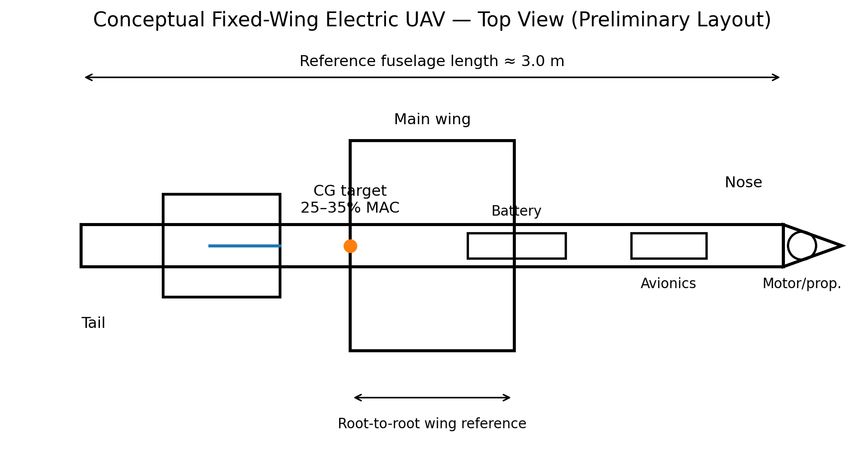
Figure 2. Preliminary top-view airframe arrangement.
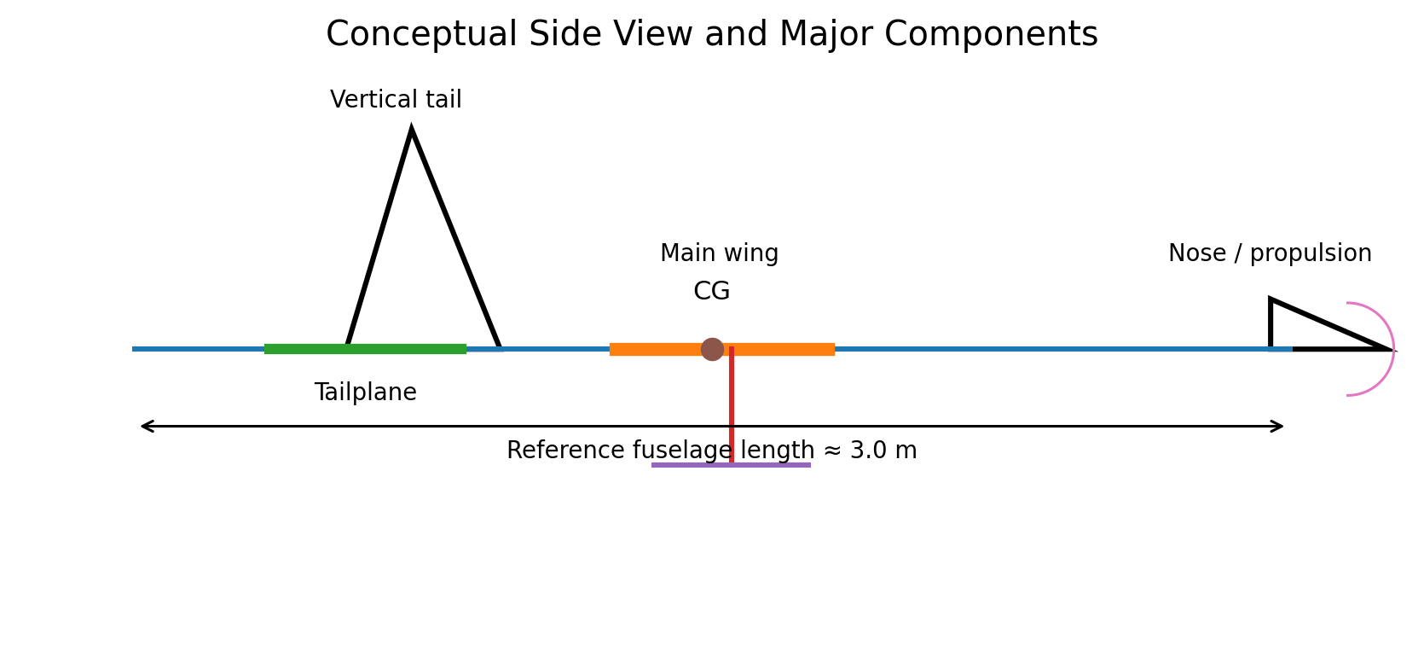
Figure 3. Preliminary side-view arrangement.
The layout deliberately separates high-current propulsion hardware from sensitive avionics while keeping the battery near the design CG. The final locations must be adjusted after the actual component masses and dimensions are known.

8. Preliminary Engineering Calculations
All calculations below are first-order sizing calculations. Values should be updated when the mission requirements and selected hardware become available.

8.1 Weight
Assumed maximum take-off mass:
m = 12 kg
Weight: W = mg = 12 × 9.81 = 117.72 N
Therefore, the preliminary design weight used in the aerodynamic equations is W = 117.72 N.

8.2 Main-Wing Area from Stall-Speed Requirement
For steady level flight at stall:
L = W = ½ ρ Vₛ² S C_L,max
Rearranging:
S = W / (½ ρ Vₛ² C_L,max)
Using W = 117.72 N, ρ = 1.225 kg/m³, Vₛ = 11.6 m/s and C_L,max = 1.30:
S = 117.72 / [0.5 × 1.225 × (11.6)² × 1.30]
S ≈ 1.10 m²
Thus, a preliminary wing area of approximately 1.10 m² is selected.
Wing loading = W/S = 117.72/1.10 ≈ 107.0 N/m² ≈ 10.9 kg/m².

8.3 Wing Span and Mean Chord
Aspect ratio is defined as:
AR = b²/S
Therefore:
b = √(AR × S) = √(8 × 1.10) = 2.97 m
For a first-order rectangular-equivalent wing:
c ≈ S/b = 1.10/2.97 = 0.371 m
Preliminary geometry: span ≈ 2.97 m and mean chord ≈ 0.371 m.

8.4 Cruise Lift Coefficient
At 18 m/s:
q = ½ρV² = 0.5 × 1.225 × 18² = 198.45 Pa
C_L = W/(qS) = 117.72/(198.45 × 1.10) ≈ 0.539
The calculated cruise lift coefficient is therefore approximately C_L = 0.54.

8.5 Induced Drag and Total Drag
For the preliminary drag polar:
C_D = C_D0 + kC_L²
where k = 1/(πeAR).
With e = 0.80 and AR = 8:
k = 1/(π × 0.80 × 8) ≈ 0.0497
Induced-drag coefficient:
C_Di = 0.0497 × (0.539)² ≈ 0.0145
With C_D0 = 0.035:
C_D ≈ 0.035 + 0.0145 = 0.0495
Drag force:
D = qSC_D = 198.45 × 1.10 × 0.0495 ≈ 10.8 N
This is a preliminary cruise drag estimate.

8.6 Propulsive Power Estimate
Aerodynamic power required:
P_aero = D × V = 10.8 × 18 ≈ 194 W
Assuming overall propulsive efficiency η = 0.70:
P_shaft = P_aero/η = 194/0.70 ≈ 278 W
A practical selection would therefore require margin above the 278 W cruise requirement; for example, a preliminary motor system could be in the ~500 W class, subject to propeller, battery voltage, climb requirement and thermal analysis.
This is not a final motor recommendation; climb and take-off power must be calculated separately.

8.7 Tail-Volume Sizing
Horizontal-tail volume coefficient:
V_H = (S_H l_H)/(S c)
Using a preliminary V_H = 0.60, S = 1.10 m², c = 0.371 m and l_H = 1.00 m:
S_H = V_H S c / l_H = 0.60 × 1.10 × 0.371 / 1.00 ≈ 0.245 m²
Thus, a preliminary horizontal-tail area of about 0.25 m² is selected for the concept study.
Vertical-tail volume coefficient:
V_V = (S_V l_V)/(S b)
Using V_V = 0.04, S = 1.10 m², b = 2.97 m and l_V = 1.00 m:
S_V = 0.04 × 1.10 × 2.97 / 1.00 ≈ 0.130 m²
Thus, a preliminary vertical-tail area of about 0.13 m² is selected.

8.8 CG Location
For preliminary stability layout, the target CG is placed between 25% and 35% of the mean aerodynamic chord, pending a proper neutral-point and static-margin calculation.
With c = 0.371 m:
25% MAC = 0.25 × 0.371 = 0.093 m
35% MAC = 0.35 × 0.371 = 0.130 m
Therefore, the initial target CG region is approximately 0.093–0.130 m aft of the wing leading-edge reference at the chosen aerodynamic station.
The actual CG must be computed from component masses and moment arms before flight.

9. Preliminary Design Summary
Item | Preliminary value | Status
MTOW mass | 12 kg | Assumption
Weight | 117.72 N | Calculated
Wing area | 1.10 m² | Calculated
Aspect ratio | 8 | Assumption
Wing span | 2.97 m | Calculated
Mean chord | 0.371 m | Calculated
Stall speed | 11.6 m/s | Design target
Cruise speed | 18 m/s | Design target
Cruise CL | 0.539 | Calculated
CD0 | 0.035 | Assumption
Induced CD | 0.0145 | Calculated
Total CD | 0.0495 | Calculated
Cruise drag | 10.8 N | Calculated
Aerodynamic cruise power | 194 W | Calculated
Estimated shaft power | 278 W | Calculated
Horizontal tail area | 0.245 m² | Preliminary sizing
Vertical tail area | 0.130 m² | Preliminary sizing
Target CG | 25–35% MAC | Initial stability target

10. Packaging and Systems Integration Plan
Subsystem | Proposed location | Design reason
Battery | Near CG, accessible bay | Mass is large; moving it strongly changes CG.
Flight controller | Protected central fuselage | Short sensor/wiring paths and reduced vibration exposure.
GNSS/GPS | Upper fuselage with clear sky view | Reduces obstruction and electromagnetic interference.
Radio/telemetry | Away from high-current power wiring | Reduces potential interference.
ESC | Near motor with cooling path | Reduces high-current wire length and heat accumulation.
Motor/propeller | Nose / tractor position | Simple propulsion integration and cooling.
Payload | Near CG where practical | Reduces CG shift when payload is installed/removed.
Servos | Close to control surfaces | Reduces linkage length and mechanical complexity.
Power distribution | Central electronics bay | Simplifies wiring and protection.

11. Manufacturing and Maintainability Considerations
- Use modular wing attachment so the aircraft can be transported and inspected.
- Provide removable access panels for battery, ESC, flight controller and wiring.
- Keep wiring secured and separated from moving control mechanisms.
- Provide strain relief at connectors and cable exits.
- Ensure the propeller arc is physically isolated from electronics and structural components.
- Design control-surface hinges and linkages so they can be inspected before operation.
- Maintain a clear record of component mass, location and moment arm so the CG can be recalculated after every configuration change.
- Use a configuration-control table to record every major change to geometry or hardware.

12. Tools and Software
Tool | Purpose
CAD: Fusion 360 / SolidWorks / FreeCAD | 3D airframe geometry, packaging and drawings
OpenVSP | Conceptual aircraft geometry and aerodynamic analysis
XFLR5 | Preliminary low-speed wing/airfoil analysis
Python / Excel | Sizing calculations, sensitivity studies and mass properties
MATLAB/Simulink (if available) | Parametric analysis and flight/control studies
GitHub | Version control and engineering documentation where permitted

13. Week-by-Week Plan
Week | Activity | Deliverable | Success check
Week 1 | Requirements, airframe research, assumptions, preliminary sizing | This planning report | All assumptions and equations traceable
Week 2 | Airfoil selection, wing geometry and initial CAD | Wing CAD + geometry table | Geometry matches sizing calculations
Week 3 | Fuselage, tail, control surfaces and component packaging | Complete conceptual CAD | Subsystems fit with access provisions
Week 4 | Weight & CG update, stability and aerodynamic checks | Updated analysis report | Mass properties close consistently
Week 5 | Refinement using OpenVSP/XFLR5 or equivalent | Aero comparison | Design changes justified by data
Week 6 | Final documentation and presentation | Final report + drawings | Reproducible results and clear engineering rationale

14. Risk Register
Risk | Impact | Mitigation
Actual component masses differ from assumptions | CG and wing loading change | Maintain a live mass/moment spreadsheet
Battery placement causes excessive CG shift | Stability/trim problems | Place battery near CG and recalculate each configuration
Insufficient motor/propeller performance | Poor climb/take-off | Perform thrust and power analysis before hardware selection
Structural weight becomes too high | Performance decreases | Iterate structural sizing and material selection
Electronics interference / thermal issues | Control or reliability problems | Separate power and signal routing; provide cooling and shielding where appropriate
Regulatory mismatch | Vehicle may not be legally operable | Determine applicable aviation/UAS rules before any real flight testing

15. Expected Deliverables for the Next Stage
- Fully dimensioned three-view drawing.
- 3D CAD assembly with named components.
- Mass-properties spreadsheet including component mass and moment arms.
- Wing and tail geometry table.
- Updated aerodynamic analysis with selected airfoil data.
- Stability and control analysis with stated assumptions.
- Propulsion sizing including thrust, current, battery voltage and endurance estimates.
- Structural load cases and preliminary sizing.
- Final configuration-control and revision table.

16. Conclusion
The proposed layout establishes a traceable starting point for a conventional fixed-wing electric UAV. The study begins with explicit requirements and assumptions, then derives wing area, span, chord, cruise lift coefficient, drag, power and preliminary tail areas. The layout also considers CG, electronics packaging, maintainability and future CAD/aerodynamic validation. The next design iteration should replace all assumed values with measured or selected component data and perform higher-fidelity aerodynamic, stability and structural analysis.
The key engineering principle is that the airframe layout is not only a drawing: it is a coordinated arrangement of aerodynamic surfaces, structure, propulsion, electronics, payload, mass properties, control systems and maintainability requirements.

17. References
- Federal Aviation Administration (FAA), Small Airplanes — Regulations, Policy, and Guidance. https://www.faa.gov/aircraft/air_cert/design_approvals/small_airplanes/small_airplanes_regs
- European Union Aviation Safety Agency (EASA), CS-23 Amendment 6 and AMC & GM to CS-23 Issue 5. https://www.easa.europa.eu/en/document-library/certification-specifications/cs-23-amendment-6-and-amc-gm-cs-23-issue-5
- EASA, Easy Access Rules for Normal-Category Aeroplanes (CS-23), Amendment 6. https://www.easa.europa.eu/en/document-library/easy-access-rules/easy-access-rules-normal-category-aeroplanes-cs-23
- FAA, Small Airplanes — certification and associated guidance. https://www.faa.gov/aircraft/air_cert/design_approvals/small_airplanes
- Anderson, J. D., Introduction to Flight, for standard preliminary aircraft-performance relationships.
- Raymer, D. P., Aircraft Design: A Conceptual Approach, for conceptual sizing and configuration methods.

END OF WEEK 1 DELIVERABLE

